Initial Gantt Chart

A Gantt chart was used as a design method to plan out the waterfall process of development, and allocate amount of time for each stage of development. The following is the initial Gantt chart, made at the start of development, and below is the revised Gantt chart, edited as development progressed to reflect changes made to the plan.

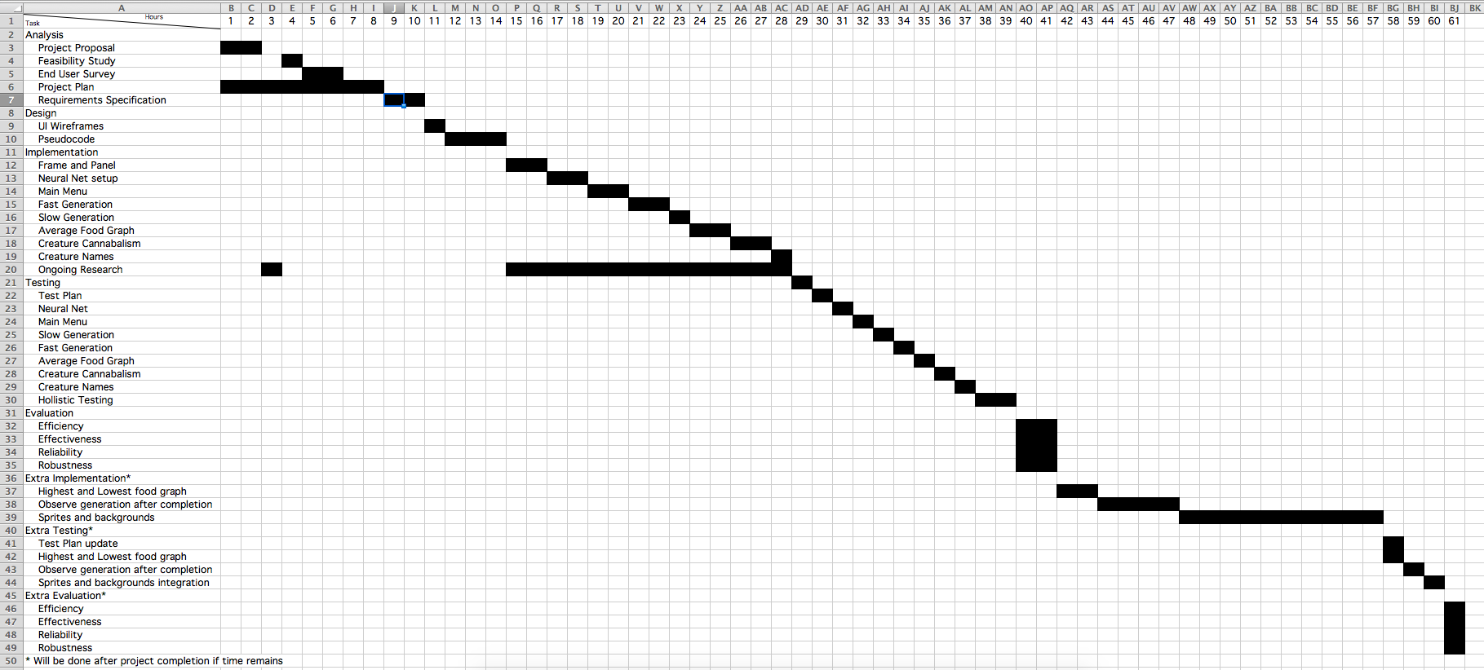

Revised Gantt Chart

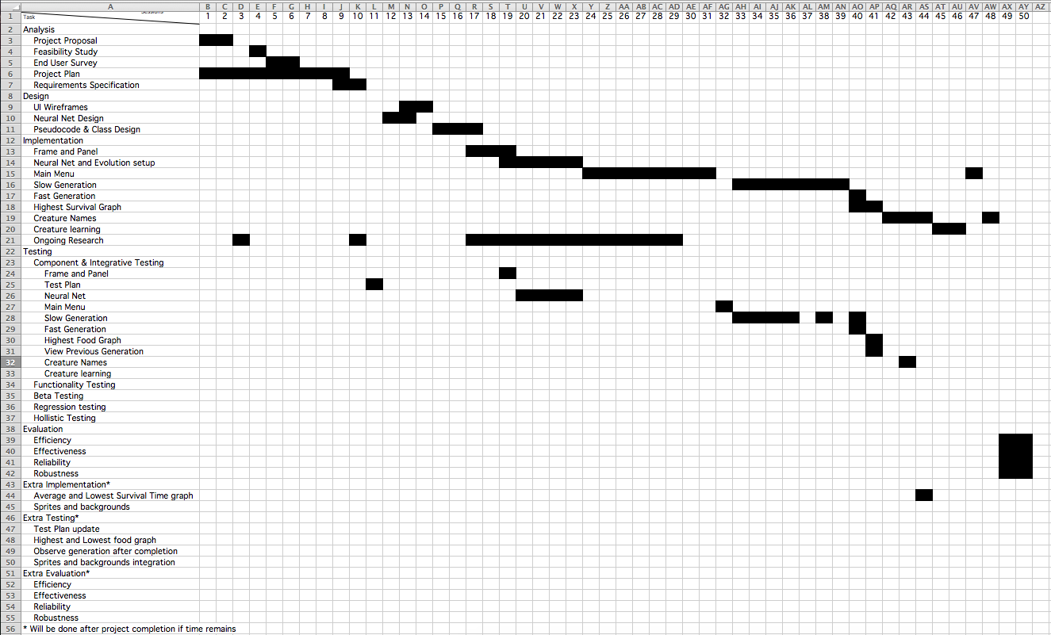

The main noticeable difference is that the revised Gantt chart is a lot less flowing and represents a waterfall model of design less. This is because it was realised that most of the testing should be done concurrently with the implementation, as each component should be tested before moving on to the next. It can also clearly be seen that the additional features were not actually implemented during the real development.